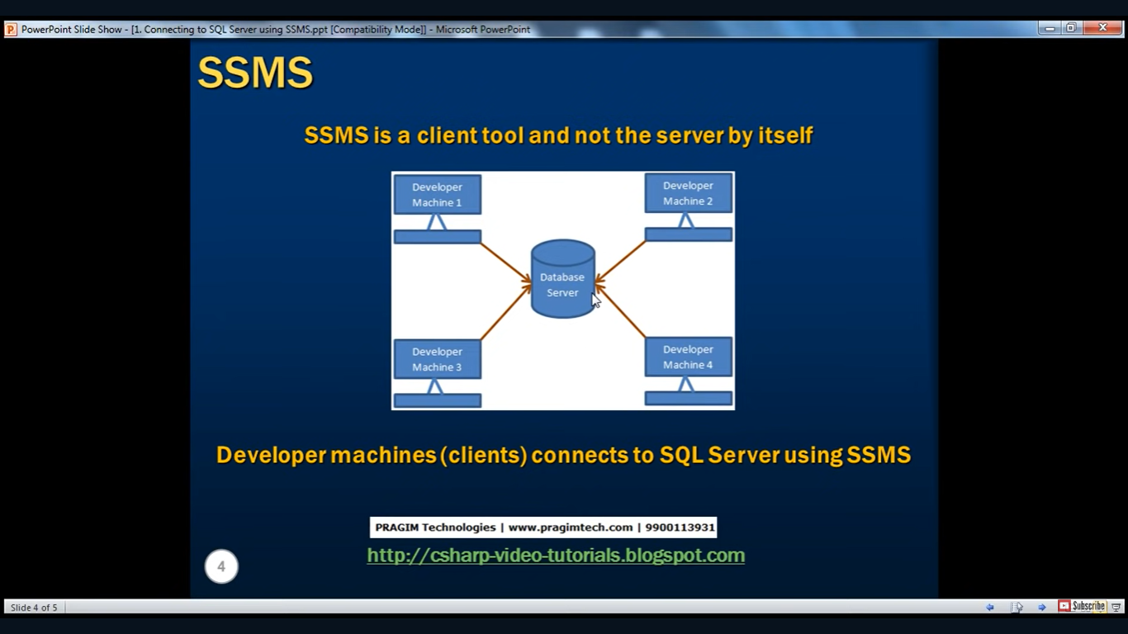

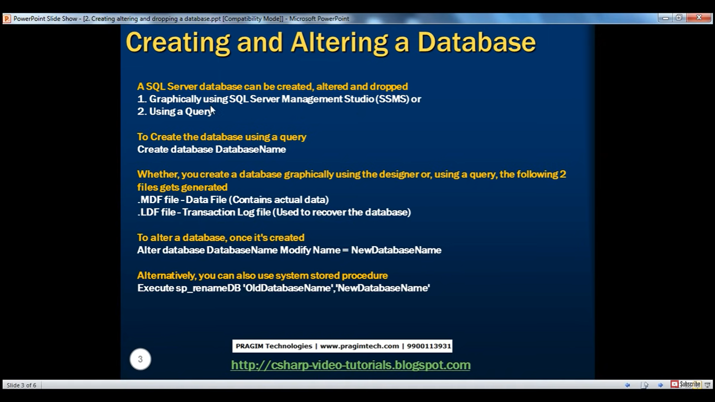

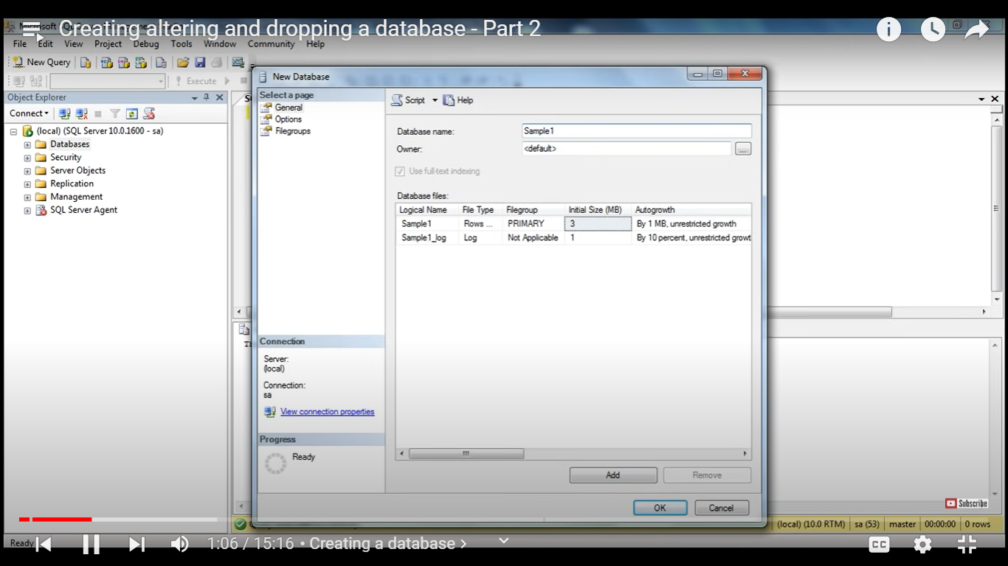

**Creating a database using query**

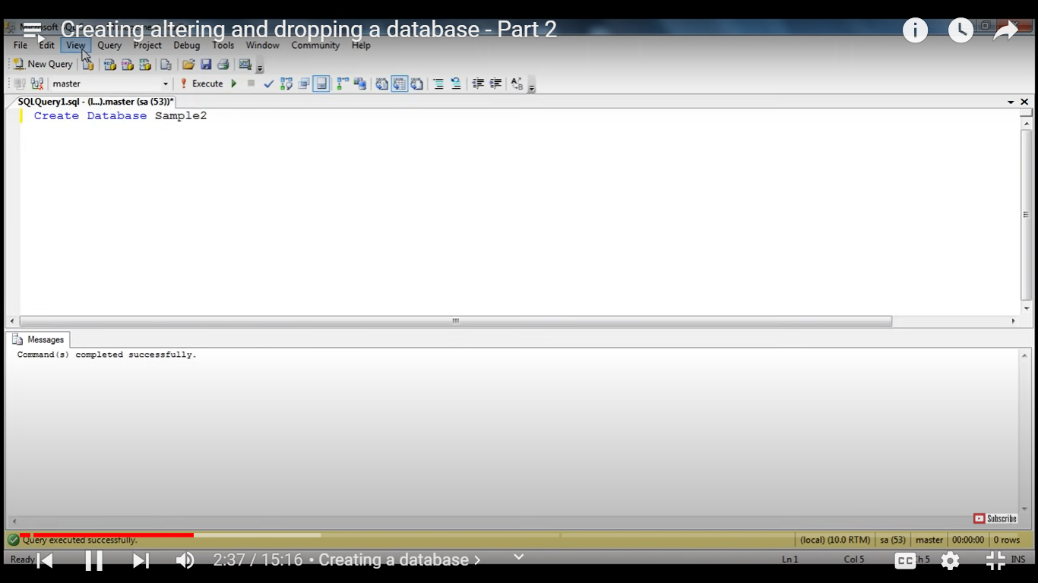

There are two datavase system database and user defined database (which user creates)

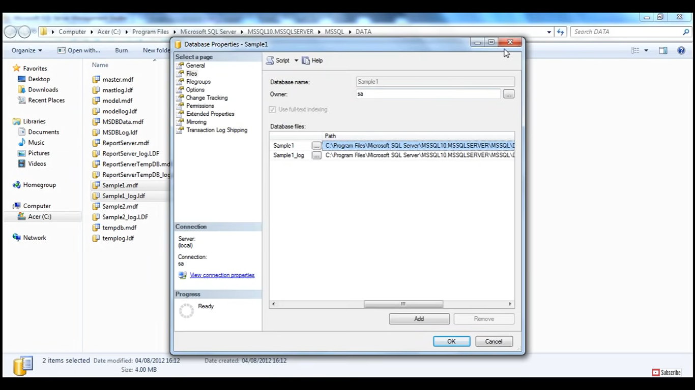

MDF – master data File

LDF – log data file

Renaming Database name

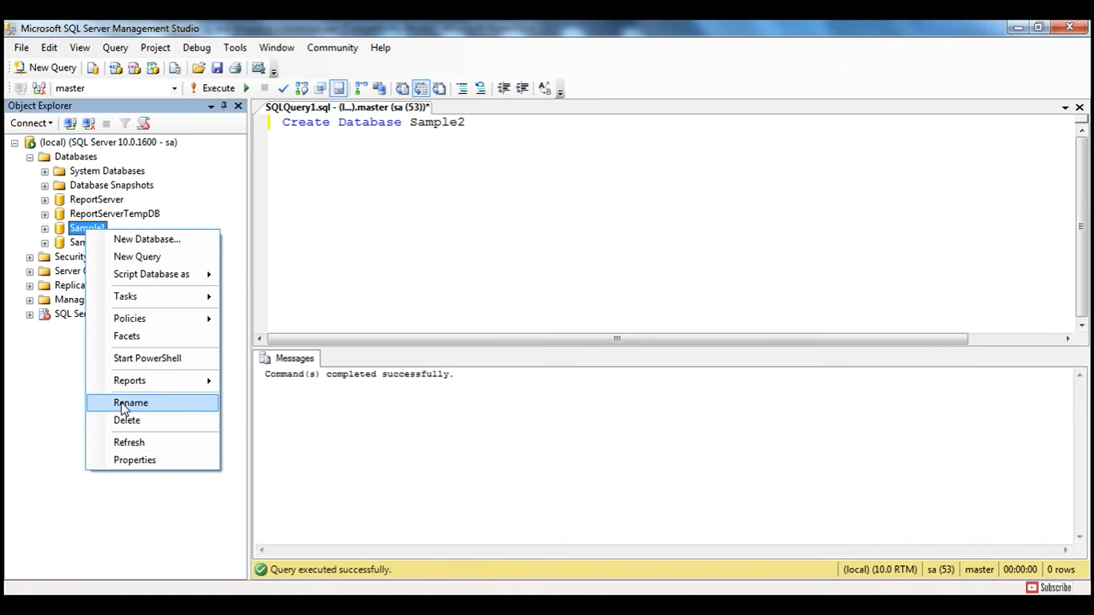

Rename database using query

--using query

Alter Database Sample2 Modify Name = Sample3

--using stored procedures

Execute sp_renamedb 'Sample3','Sample2'

**Deleting or Dropping a Database**

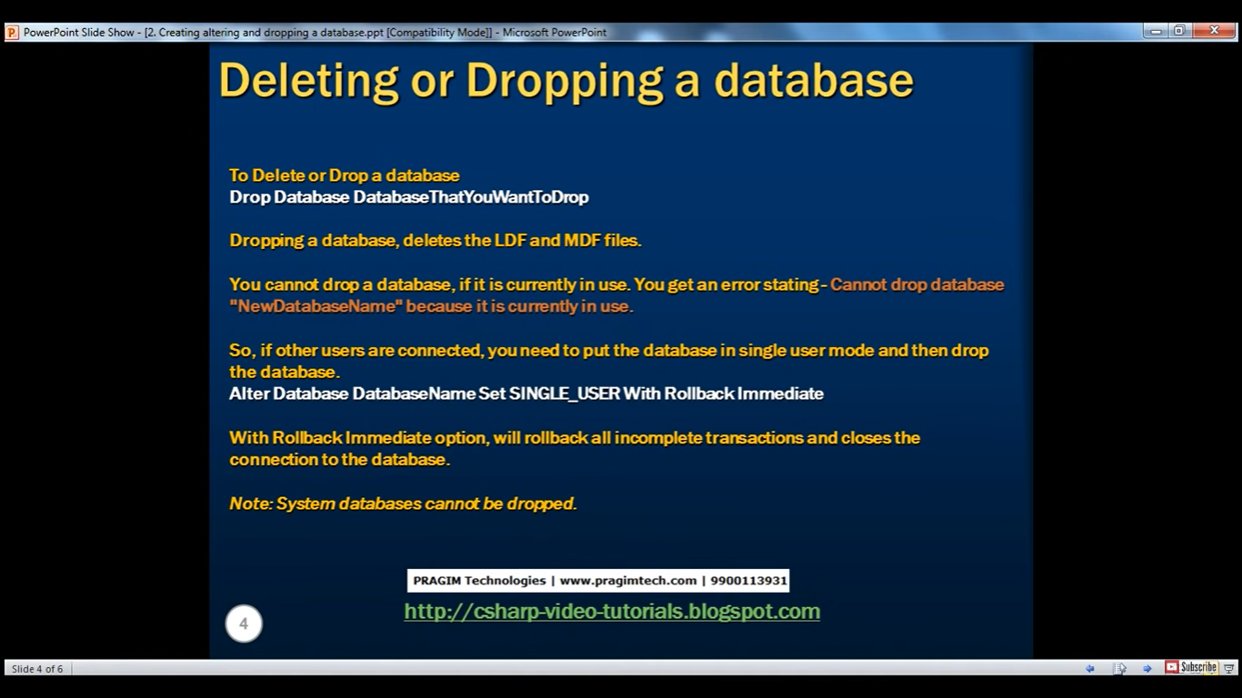

Directly using GUI

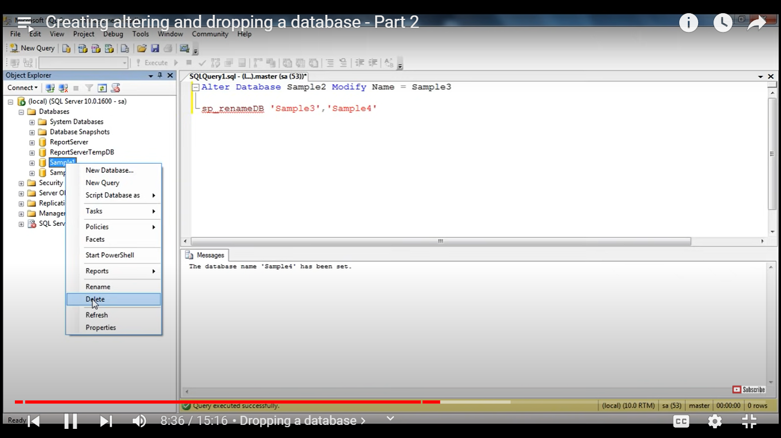

--Dropping database using query

Drop Database Sample2

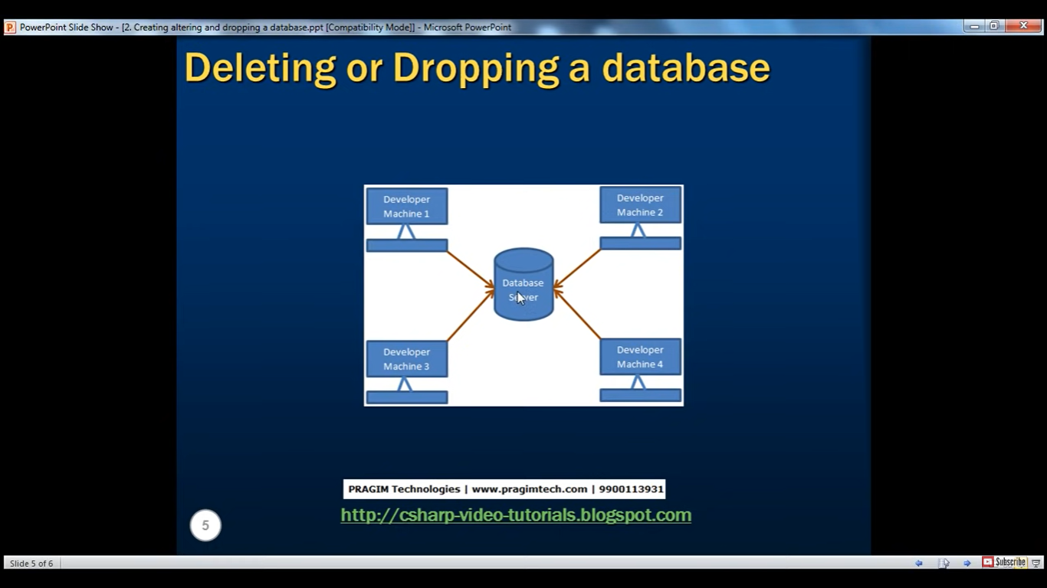

We cannot drop a database if it is currently in use.

So if other users are connected, we need to put the database in single user mode and the ndrop the database

Alter Database DatabaseName Set SINGLE_USER With Rollback Immediate

System databases cannot be dropped.